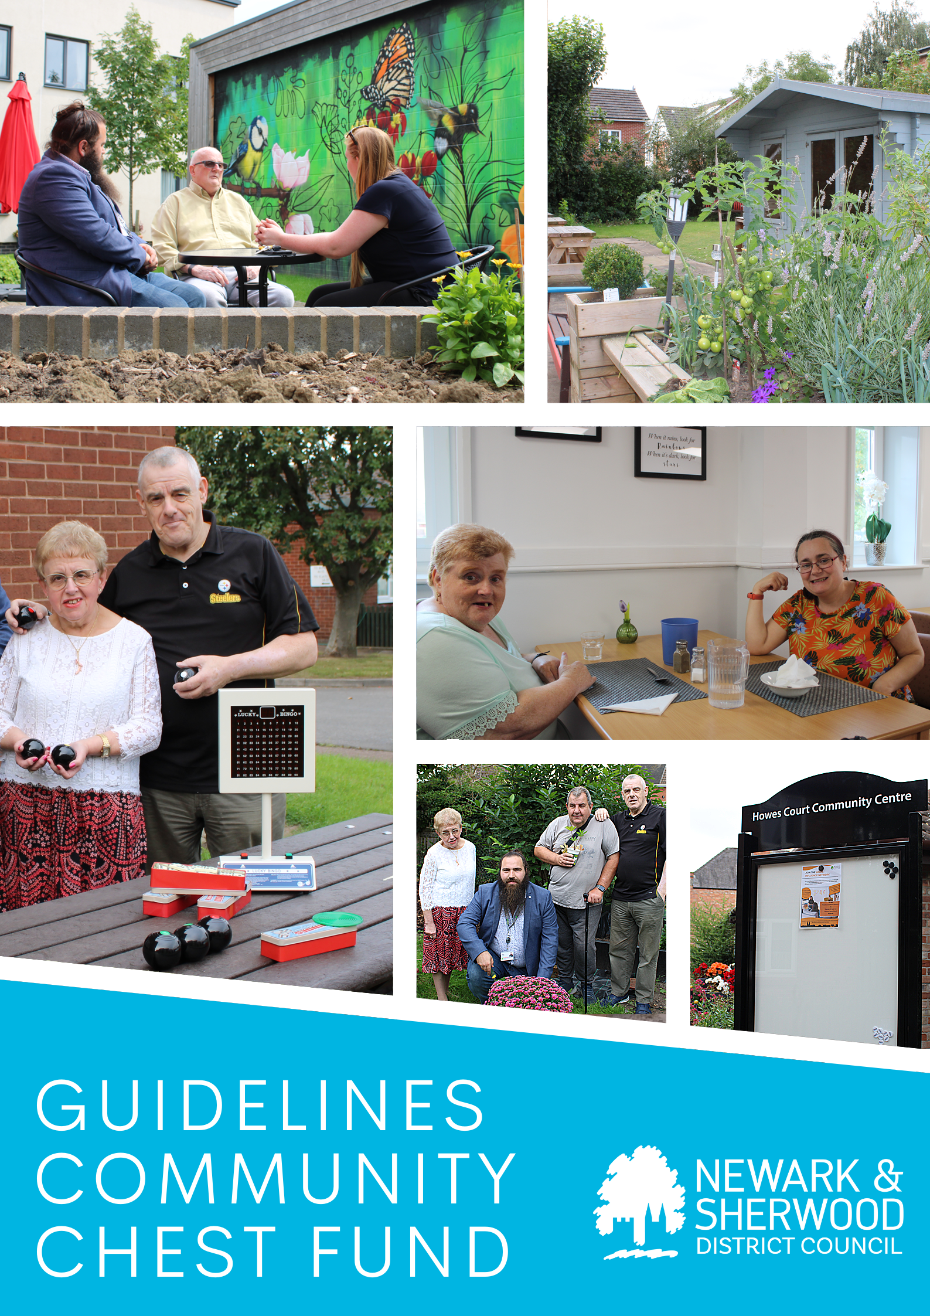

COMMUNITY CHEST GUIDELINES

About Newark and Sherwood District Council Housing

Newark and Sherwood District Council provides social housing to over 5500 tenants across 284 square miles of the district. These include general housing, supported housing and housing with care and support.

What is the Community Chest Fund?

The Community Chest Fund is designed to give Tenants, Councillors and our support staff the opportunity to identify areas that may be made better, safer, cleaner and greener by the injection of a small amount funding up to £1000. The money is provided from the Housing Revenue Account so must be spent on improving the amenities of social housing tenants or areas which social housing tenants use.

The Community Chest project must aim to deliver outcomes on at least one of the following themes:
- It will support a community development and or empowerment project e.g.
  - a collective action working to resolve an identified community issue.

- It will support projects and initiatives which aim to:
  - reduce anti-social behaviour around social housing
  - support the provision of safety and security measures
  - increase the wellbeing and mental health of our tenants and leaseholders
  - to carry out local sustainability projects particularly around identified issues such as waste management, litter, dog fouling and environmental issues.
  - support the development of digital and financial Inclusion projects with vulnerable groups or individuals
  - support tenants into Education, Learning and Volunteering opportunities support the delivery targeted health and wellbeing outcomes to vulnerable tenants or groups of tenants.

Essential Criteria:
- The project is in a community where Newark and Sherwood District Council housing is represented.
- The application must demonstrate demand for the project in the local community and supported and in consultation with tenants.
- Projects must be inclusive and accessible to all.
- Project can show that value for money will be achieved.
- Project must be delivered within 12 months of award.

The projects funding size

Up to £1000

Who can apply for support?

  - Tenants and leaseholders
  - Residents (if they can prove their project will significantly benefit tenants and leaseholders)
  - Elected members
  - Support Officers
  - Other Council Officers when applying to benefit tenants and leaseholders

Newark and Sherwood District Council will not support:

- Core funding or general running costs.
- Professional fees
- Building or capital work.
- Political or religious activities.
- Commercial Organisations.
- Work considered to be a statutory responsibility.

How the funding is administered:

- Funding will be spent by Newark and Sherwood District Council. Once an application is received, the Tenant Engagement Team will consider it in line with these guidelines and a report will be presented at a panel involving Councillors and Tenants. Once a decision is made you will receive an email advising of the nest steps. The work will be carried out by a Council assigned contractor or in some cases internal contractors and paid directly by Newark and Sherwood District Council.
- In cases where funding is requested to ‘match fund’ a project which will benefit tenants and leaseholders, funding may be provided, once approved to properly constituted groups or organisations’ which can verify who the beneficiaries are, and the application is supported by a tenant or leaseholders.

Applicants must provide the following when submitting their application:

- A completed form. Please speak with a member of the Tenant Engagement Team in the first instance on getinvolved@newark-sherwooddc.gov.uk who will forward you a funding application form.

- Must include all with the completed application form:

  - If you are a tenant or leaseholder who just wants to improve the area, please fill in the form with as much detail and photographs (if available) as possible. Send the form back to the get involved email address. Once received the Engagement Team will process and keep you up to date with progress.

  - If you are a constituted group a copy of your governing document, e.g. constitution – this must be the name of the applicant organisation unless governed through an umbrella organisation.
    - A current account bank statement dated within the last 3 months.
    - A copy of the organisations’ most recent audited accounts.
    - All information submitted must have the same group/association name.

- Projects must show value for money, therefore Newark and Sherwood District Council will arrange for quotes for the work to be done, unless part of a match funding request.

- Application declaration statements. We will ask you to confirm a number of statements.

Monitoring Evaluating & Reporting

  - We really want to know if the project or improvement makes a difference. We will contact you after the work has been completed to see if this done what you hoped it would. Does it make you feel safer? Is the area cleaner or is it greener?

  - Photographs: We would like to receive or to get photographs of the completed work for our records and even report it in our housing publications to show other tenants what can be achieved.

  - We would also request that successful applicants promote their award as widely as possible including through social media channels.

More information. Further Information
To find out more and to get an application form please contact:

Newark and Sherwood Tenant Engagement Team
Email: getinvolved@newark-sherwooddc.gov.uk

