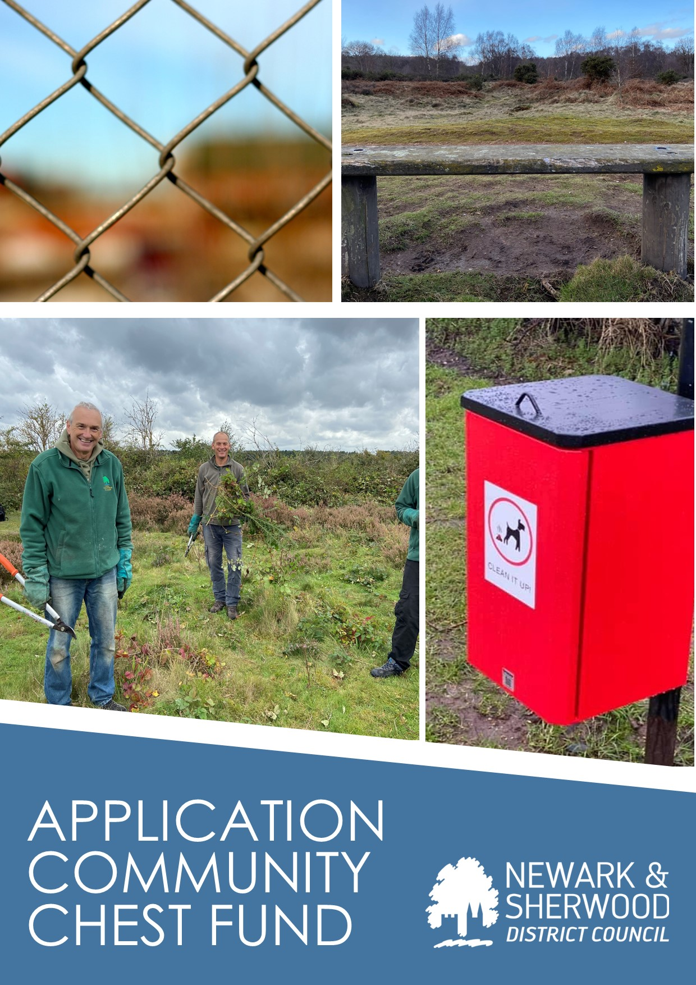

COMMUNITY CHEST APPLICATION FORM

Notes:

- If you are a Newark and Sherwood District Council (NSDC) tenant or leaseholder that just wants something doing in line with our guidelines, then complete section 1 only.

- If you are a group, that wants match funding to support our tenants and leaseholders with a project fill in section 1 and 2.

- If you are an Officer, Councillor or other partner fill in section 1.

SECTION ONE

Name of applicant

Mobile number Email address

Address:
Farrar Close Newark NG24 2EQ

Describe how your Community Chest project comes under at least one of the following themes:
1. It will support a community development and or empowerment project e.g.

- a collective action working to resolve an identified community issue.

2. It will support projects and initiatives which aim to:
- reduce anti-social behaviour around social housing
- support the provision of safety and security measures
- increase the wellbeing and mental health of our tenants and leaseholders
- to carry out local sustainability projects particularly around identified issues such as waste management, litter, dog fouling and environmental issues.
- support the development of digital and financial Inclusion projects with vulnerable groups or individuals
- support tenants into education, learning and volunteering opportunities
- support the delivery targeted health and wellbeing outcomes to vulnerable tenants or groups of tenants.

Support Education, Learning and Volunteering

Health and Wellbeing

Essential Criteria
- Is your project within a community where Newark and Sherwood Housing Services is represented? (Please state)

- What evidence do you have of demand for your project in the local community? Have you consulted with tenants? Evidence can be submitted separately if necessary.

- Outline how your project will achieve value for money.

COMPLETE AND SIGN THE APPROPRIATE LINE.

I confirm I am a tenant or leaseholder of Newark and Sherwood District Council and I am making a request with the support of other tenants and leaseholders from my community.

Name_______________________________________________________

Address _____________________________________________________

Rent or Lease Number__________________________________________
_
Signed ______________________________________________________

Or
I confirm I am an Elected Member of Newark and Sherwood District Council and am making this request with the knowledge and support of tenants of Newark and Sherwood District Council.

Name_______________________________________________________

Signed______________________________________________________

Or

I can confirm I am an Officer of Newark and Sherwood District Council and am making this request with the knowledge and support of tenants and leaseholders to whom this project refers.

Name:

Signed ____________________________________________________

Return this form to getinvolved@newark-sherwooddc.gov.uk

If you are making this request on behalf of a community group or organisation please complete section two.

SECTION TWO
- Have you sought funding from other funders? (If yes, please state)

- Are there any statutory agencies involved in your project? (Please state)

- Are there any other participants/groups going to be involved in your project?

- Number of volunteers:
7. Estimated number of volunteers to be involved in project:

- Estimated number of participants to be involved in project:

- Will your project be delivered within the next 12 months?

Yes

No

- Are you eligible to apply for a grant? (Please tick where applicable)

- We are a constituted community association/group or voluntary organisation
No
Yes

- We are a non-constituted group and will adhere to NSDC terms and conditions if successful.
No
Yes

- Have you received funding from NSDC within the previous 12 months?
No
Yes

- Annual income in the last financial year? Priority will be given to groups who had an annual income of less that £50K in the last financial year.

- If you have you received any grant from NSDC within the last 12 months? How much did you receive and what was this for?

- Please list any goods or services that you require for your project. (We require two quotes for auditing purposes)

As an organisation/Group, if you are successful we will contact you with regards to your banking details.

Application checklist for Community Organisations Only

Does your project you meet all the essential criteria?
Does your application deliver outcomes on at least one of the 5 identified themes?
Have you attached two quotes for each good/services requested?
Have you signed your completed application form?
Have you included bank statement from the last 3 months?
Have you included constitution (applies to constituted groups)
Have you included a copy of your most recent audited accounts if applicable?
You agree to complete our Monitoring, Evaluations and Reporting form on completion of project
You agree to share at least two images of your project and for NSDC to use these images for promotional purposes

Your name (print): _______________________________
Position within group (if applicable) __________________________
Signature: _______________________________
Date: ________________________________
Please note only applications registered and issued with a reference number by the Tenant Engagement Team will be processed.

Please send the completed form to Getinvolved@newark-sherwooddc.gov.uk
--------------------------------------------------------------------------------------------------------------------------

Office Use Only

Date Received: __________________________
Application Ref No: __________________________
Approved/Declined/More Information required _________________________

